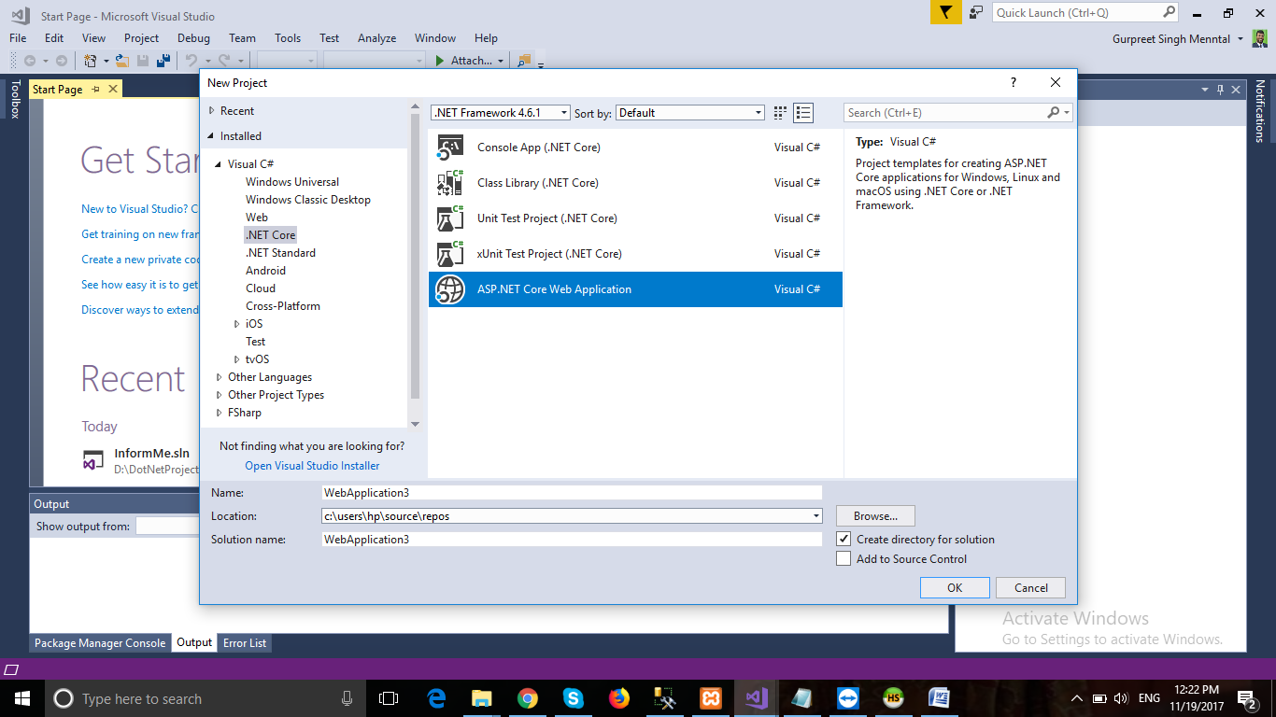

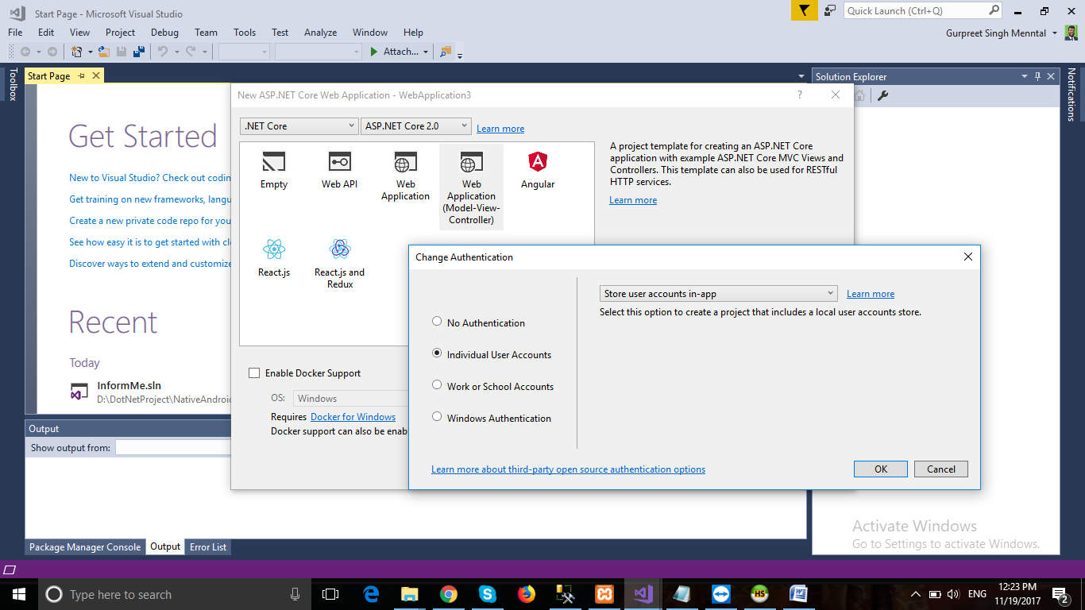

**Create project with**

* **ASP.NET Core Web Application**
* **MVC with Individual User Accounts**
* **Install this from nuget :-**
  + Pomelo.EntityFrameworkCore.MySql
  + Dapper
* **Create database in mysql**
* **Change my sql connection in appsettings.json**
  + "DefaultConnection": "server=localhost;database=Informme;User=root;password=;"
* **Replace**

options.**UseSqlServer**(Configuration.GetConnectionString("DefaultConnection")));

options.**UseMySql**(Configuration.GetConnectionString("DefaultConnection")));

**Update-database in package manager**

**Data accessing with Dapper**

**DapperConnection.cs**

using MySql.Data.MySqlClient;

using System.Data;

namespace InformMeWeb.Database

{

public class DapperConnection

{

protected MySqlConnection con = new MySqlConnection();

protected DapperConnection()

{

con.ConnectionString = "server=localhost;database=Informme;User=root;password=;";

}

protected void OpenConnection()

{

if (con.State == ConnectionState.Closed)

con.Open();

}

protected void CloseConnection()

{

if (con.State == ConnectionState.Open)

con.Close();

}

public static string Connection()

{

string s = string.Empty;

s = "server=localhost;database=Informme;User=root;password=;";

return s;

}

}

}

**GroupsClass.cs**

using System.Linq;

using Dapper;

using System;

using System.Collections.Generic;

namespace InformMeWeb.Database.Class

{

public class GroupsClass : DapperConnection

{

public Groups GetById(string id)

{

string sQuery = "SELECT * FROM Groups WHERE GroupId = @Id";

return con.Query<Groups>(sQuery, new { Id = id }).FirstOrDefault();

}

}

}